Disadvantaged Communities
Community Solar Green Tariff 2020 RFO
Workforce Development Plan Attestation

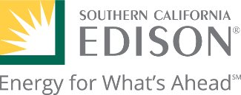

Community Solar Green Tariff Workforce Development Affidavit
Instructions: Please have the qualified participants of the below named Local Green Saver (LGS)
project complete the following with their information and demonstration of workforce development.

Local Green Saver Project Information

Developer Name

Project Name

Project Address

Size of LGS Project Number of Trainees Total Number of Job Training Hours

Primary Contact for Workforce Development

Developer Representative Name Contact Number

Email Address

Affidavit
By participating in the Local Green Saver Program as a Developer. I understand and agree to the Local Green Saver Program rules and the Local Green Saver Workforce Development guidelines reference and described herein about the workforce development and job training requirement.
I certify that I am authorized to sign this Affidavit. I also declare under the penalty of perjury, under the laws of the State of California, that all of the information in this Affidavit is true and correct to the best of my knowledge.

Name of Developer

Title

Signature (Developer Representative) Date

1 • EXTERNAL
Community Solar Green Tariff Workforce Development Affidavit

