# Summary of EFD Findings (October 2021 to year-end 2021)

|  |  |  |  |  |  |
| --- | --- | --- | --- | --- | --- |
| Evaluation Date | Substation | EFD Path | Structure Number | Evaluation Findings | Notification Number |
| 10/6/2020 | Auld | Palomino A-B | 4231374E | Conductor damage | 411205498 |
| 10/6/2020 | Auld | Palomino A-B | 213186S | Conductor damage | 411205498 |
| 1/15/2021 | Auld | Palomino B-C | 4162308E | Conductor damage | 411390363 |
| 1/19/2021 | Auld | Clydesdale A-B | 2090708E | Mylar Balloon contact | See document |
| 2/20/2021 | Casitas | Tico E-F | 4651813E | Conductor damage | 411449853 |
| 2/20/2021 | Casitas | Tico L-G | 2091322E | Conductor damage | 411453398 |
| 2/20/2021 | Casitas | Tico L-G | 2068429E | Conductor damage | 411449852 |
| 8/14/2021 | Casitas | Canet B-C | 3002918E | Primary Surge Arrester | 411774990 |
| 8/19/2021 | Casitas | Riva G-H | 4659263E | Primary Transformer Tap | 411783109 |
| 9/3/2021 | Casitas | Tico E-F | 4873362E | Vegetation Grow-In to Primary | See document |

# EFD Findings Supporting Documentation

10/6/20 – Palomino – 4231374E – conductor damage

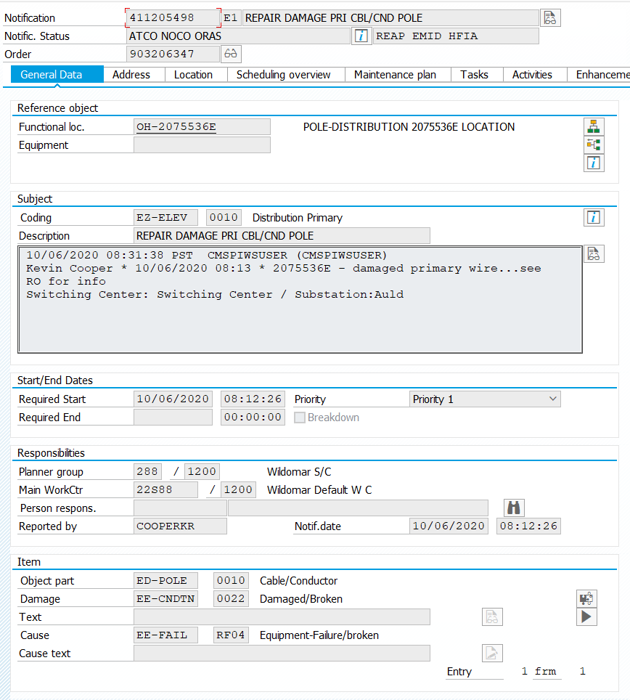

10/6/20 – Palomino - 213186S – conductor damage – same notif# as above



01/15/21 – Appalousa – 4162308E – 3 sections of damaged conductor

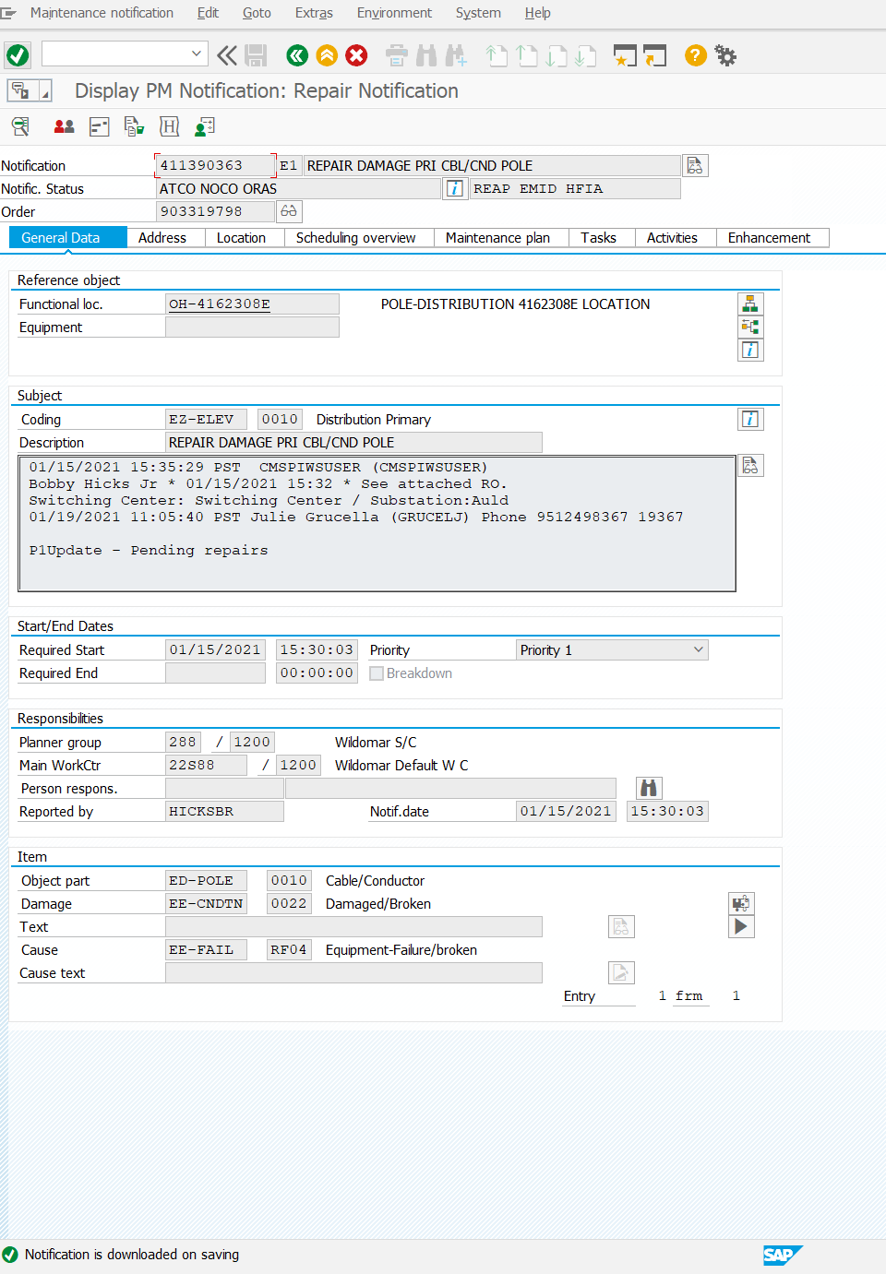

01/19/21 – Clydesdale – 2090708E – mylar balloon contact

No notification or RO generated, issue resolved by TM – see below

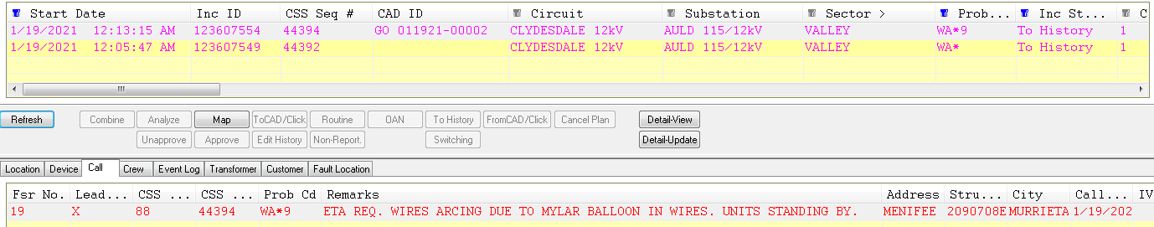

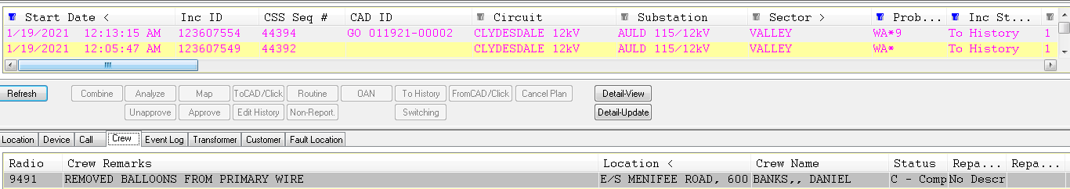

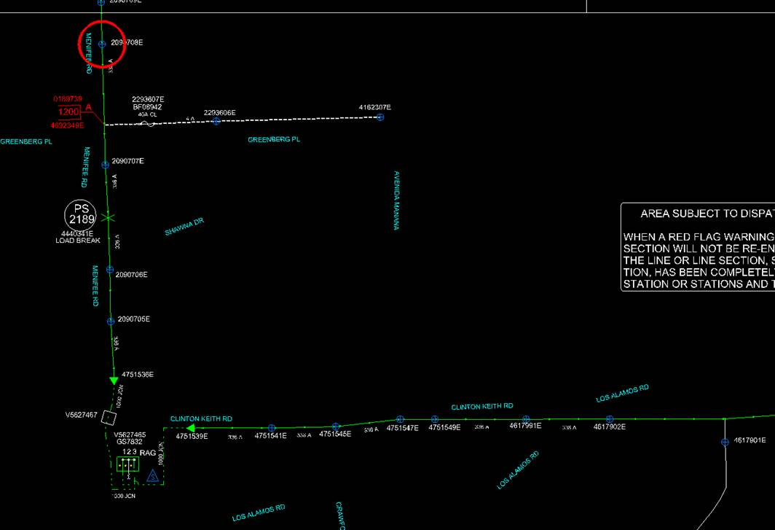

02/20/21 – Tico – 4651813E – conductor damage

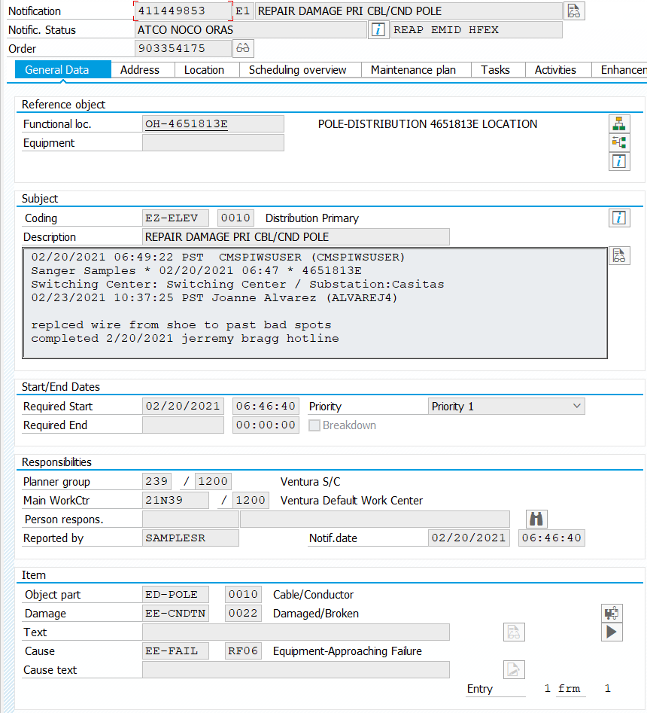

02/12/21 – Tico – 2091322E – conductor damage

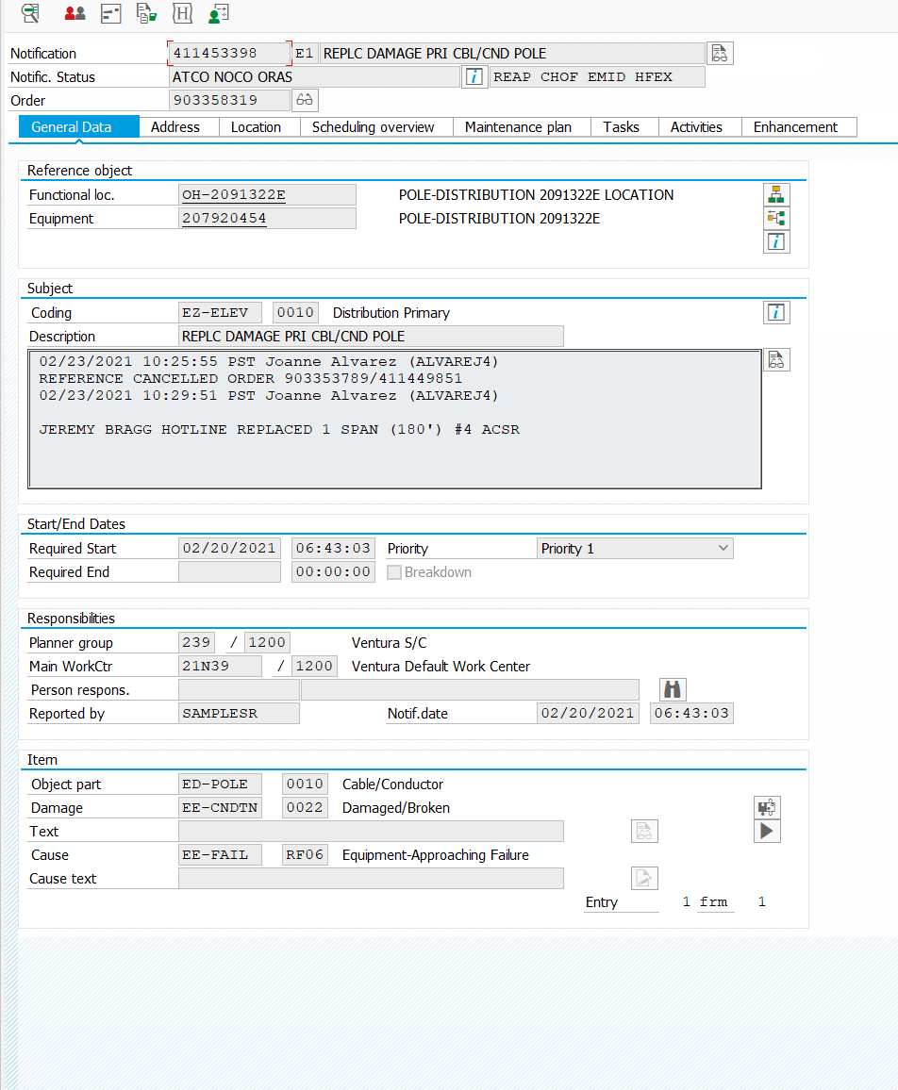

02/12/21 – Tico – 2068429E – conductor damage

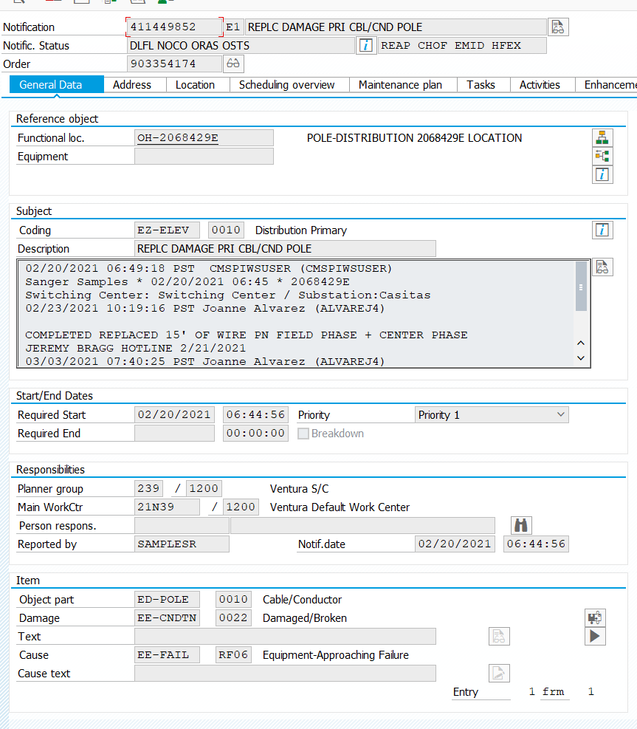

08/14/21 – Canet – 3002918E – Arrester

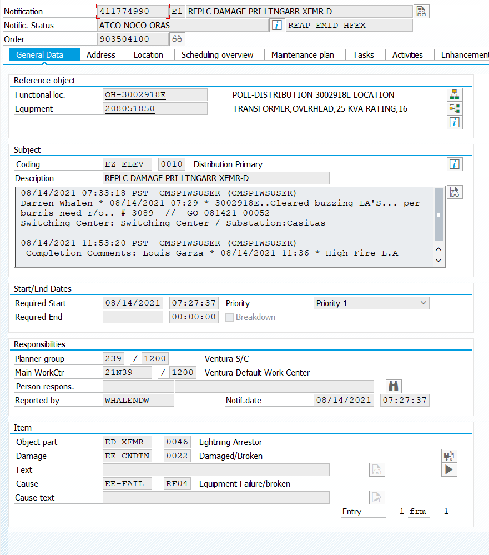

08/19/21 – Riva – 4659263E - Transformer tap

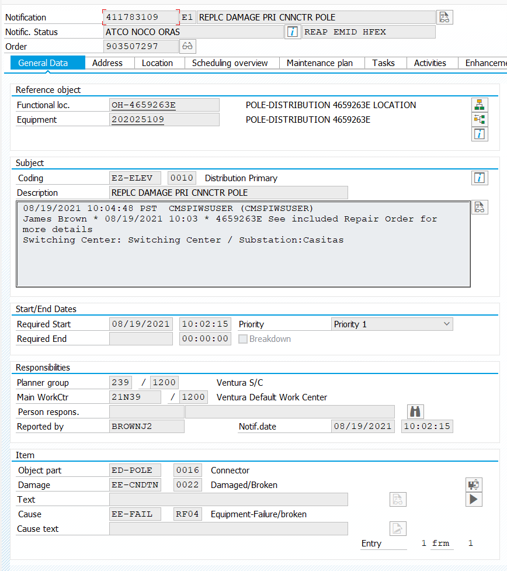

09/03/21 – Tico – 4873362E - Vegetation grow-in

Searching for notification number associated with this repair

